JENKINS PIPELINE

What is Jenkins pipeline and how does it work?
Jenkins is an open-source automation server that enables developers to reliably build, test, and deploy their software, making it a cornerstone of Continuous Integration and Continuous Delivery (CI/CD). It works by monitoring source code repositories (like Git) and triggering automated pipelines—defined by plugins—to compile code, run tests, and deploy to platforms like Docker or Kubernetes.
How Jenkins Works
Jenkins operates on a master-agent architecture to manage software development lifecycles:
- Triggering: When developers commit code to a repository (GitHub, GitLab), it triggers a Jenkins build job.
- Building:
The
Jenkins Master
node dispatches tasks to
Agents
(or slaves) to build the software, ensuring the main server isn't overloaded
.
- Testing: Automated tests (e.g., JUnit, Selenium) are executed to ensure code quality.
- Deployment: Upon successful tests, Jenkins automatically deploys the artifacts to testing or production environments.
- Plugins: Jenkins uses over 1,900+ plugins to integrate with tools like Maven, Docker, and Kubernetes.

Creating pipeline in Jenkins:

- For creating pipeline in Jenkins, ensure that we must install java, Apache tomcat, Maven applications in our system and then we install Jenkins through web browser.

- Then creating username and password in the respective applications (Jenkins and Apache tomcat) with different server ports (e.g.: localhost:8080).

- Logging in respective servers (Jenkins and tomcat).

- Install recommended plugins

  - Go to Manage Jenkins

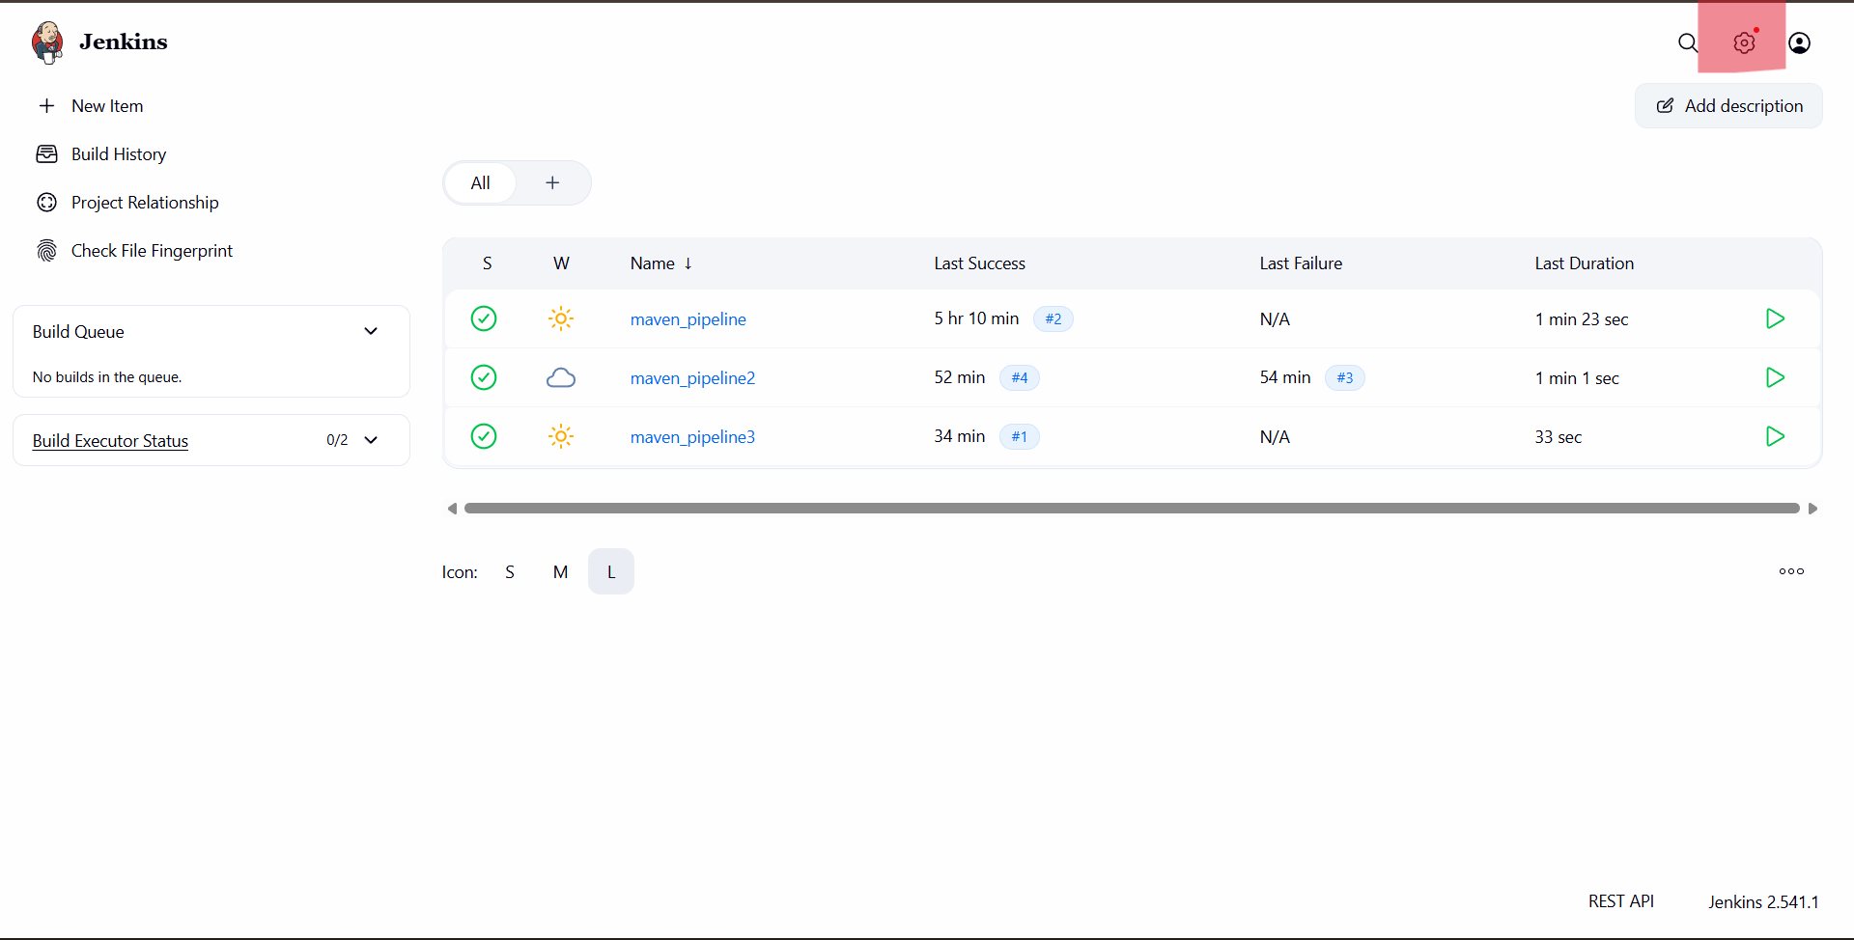

  - Click on plugins to install

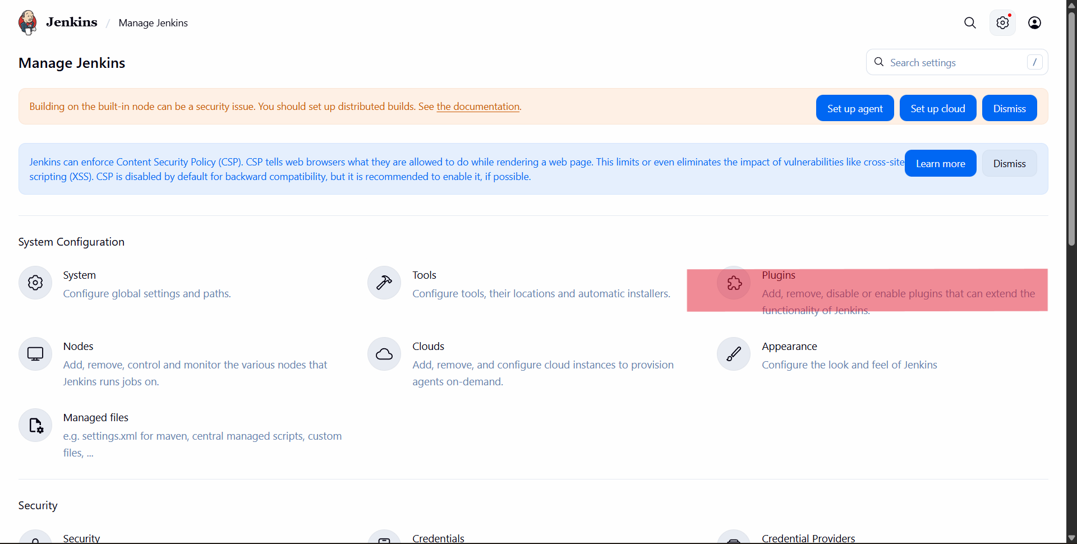

  - click on Available plugins to install

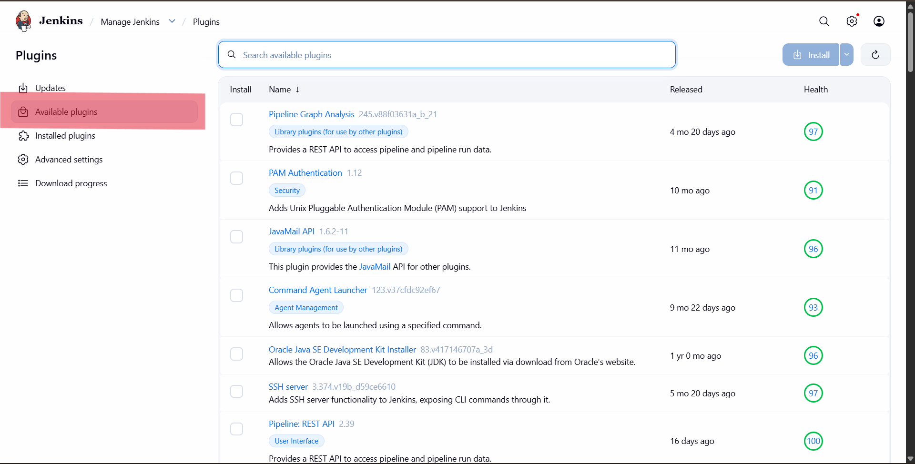

  - Search for plugins, Install and check in download progress

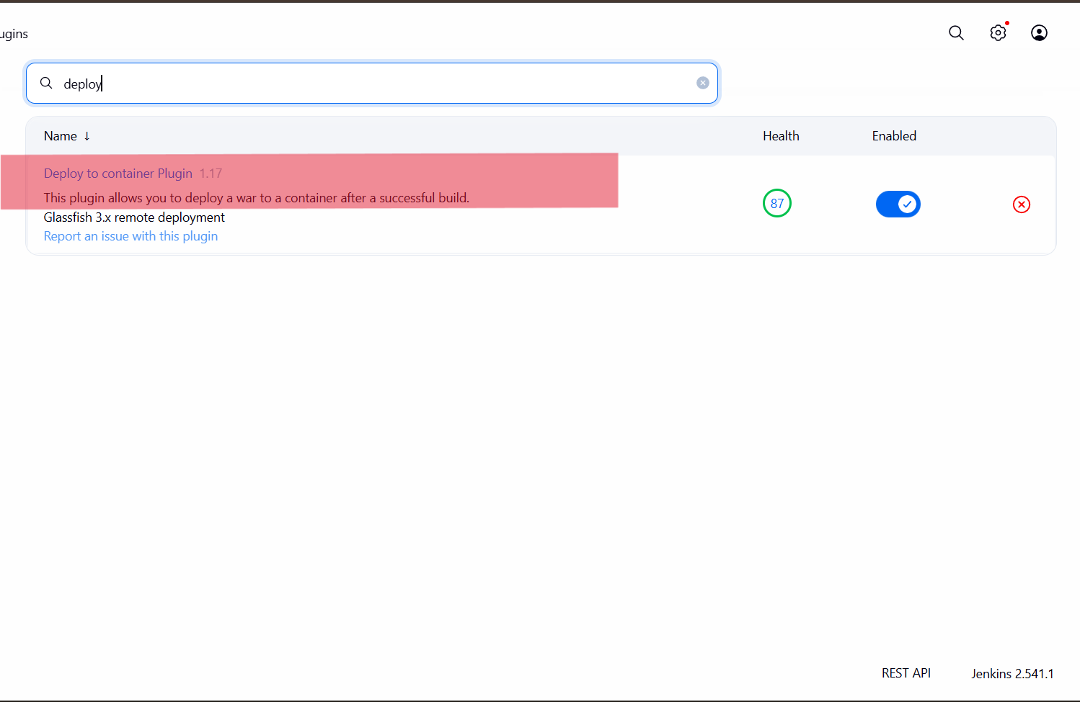

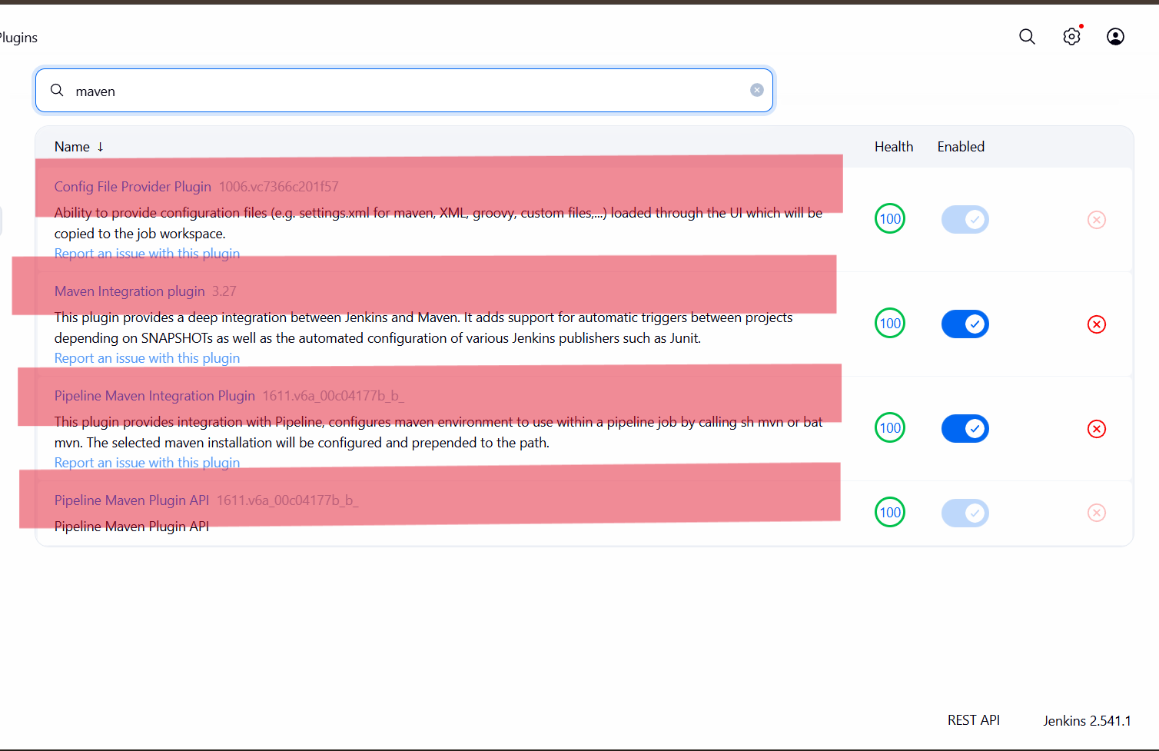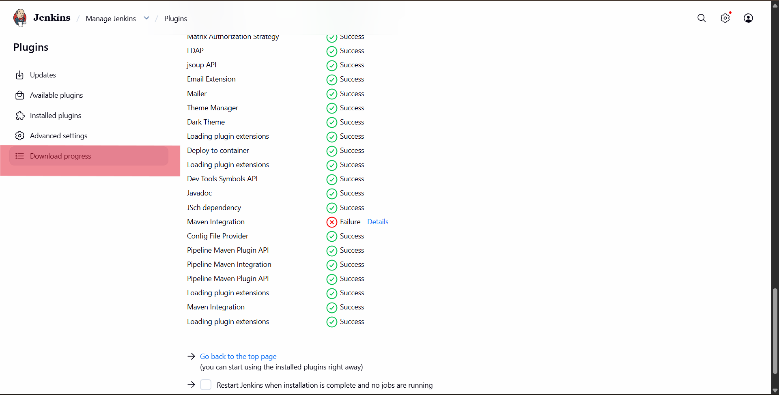

- Configure Tools and Creating item

- Click on tools to configure

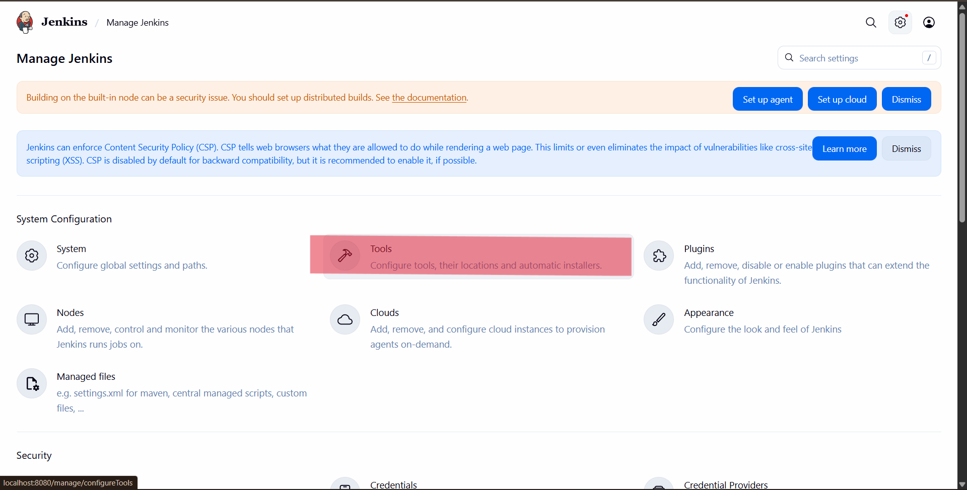

- Check Git installations and verify the path

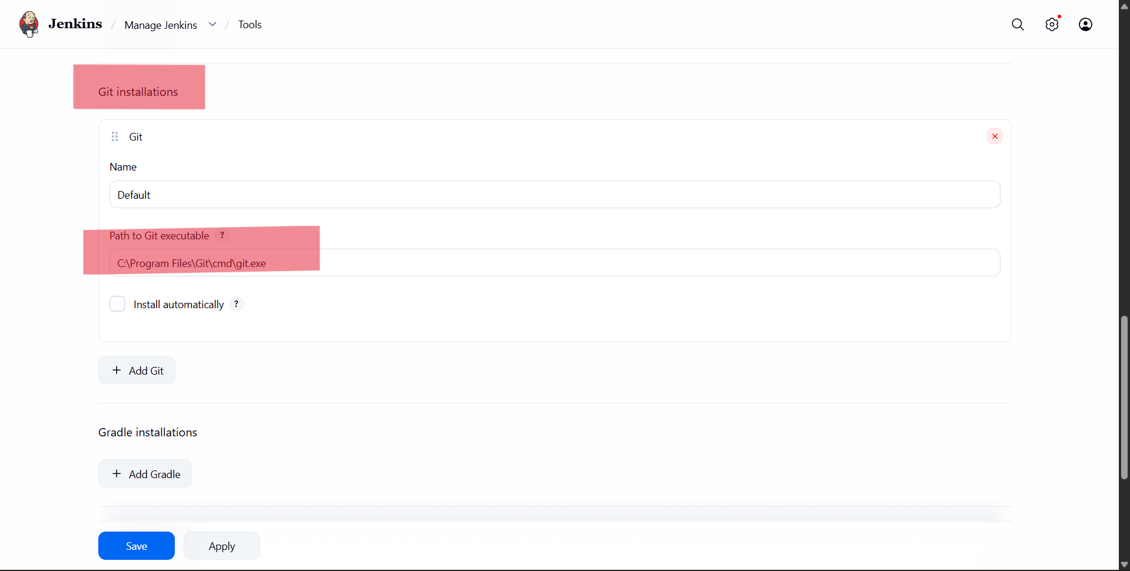

- Add Maven installations with name and Select install Automatically and save it

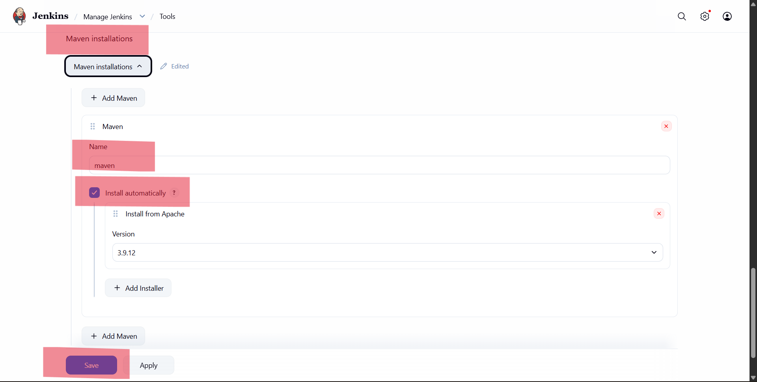

- Go back to Home page & create an item

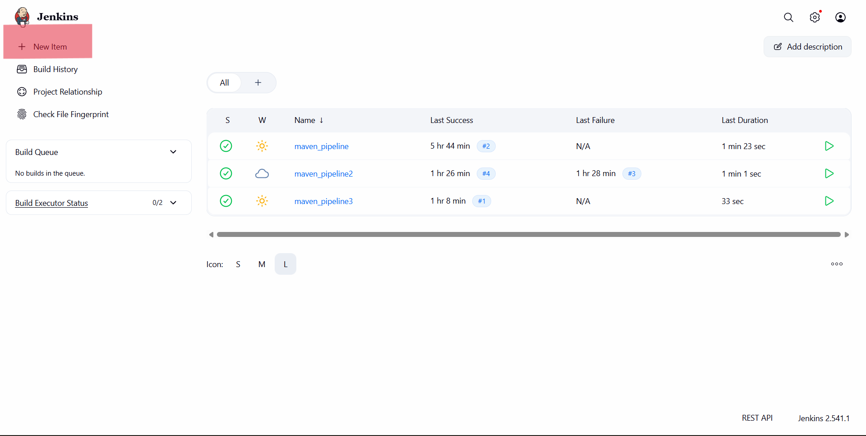

- Give an item name> select freestyle project> click on ok

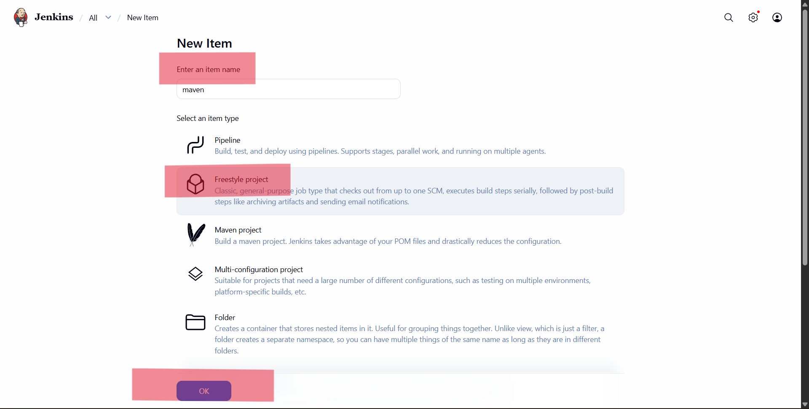

- After creating an item, redirecting into this page
General> Give any description

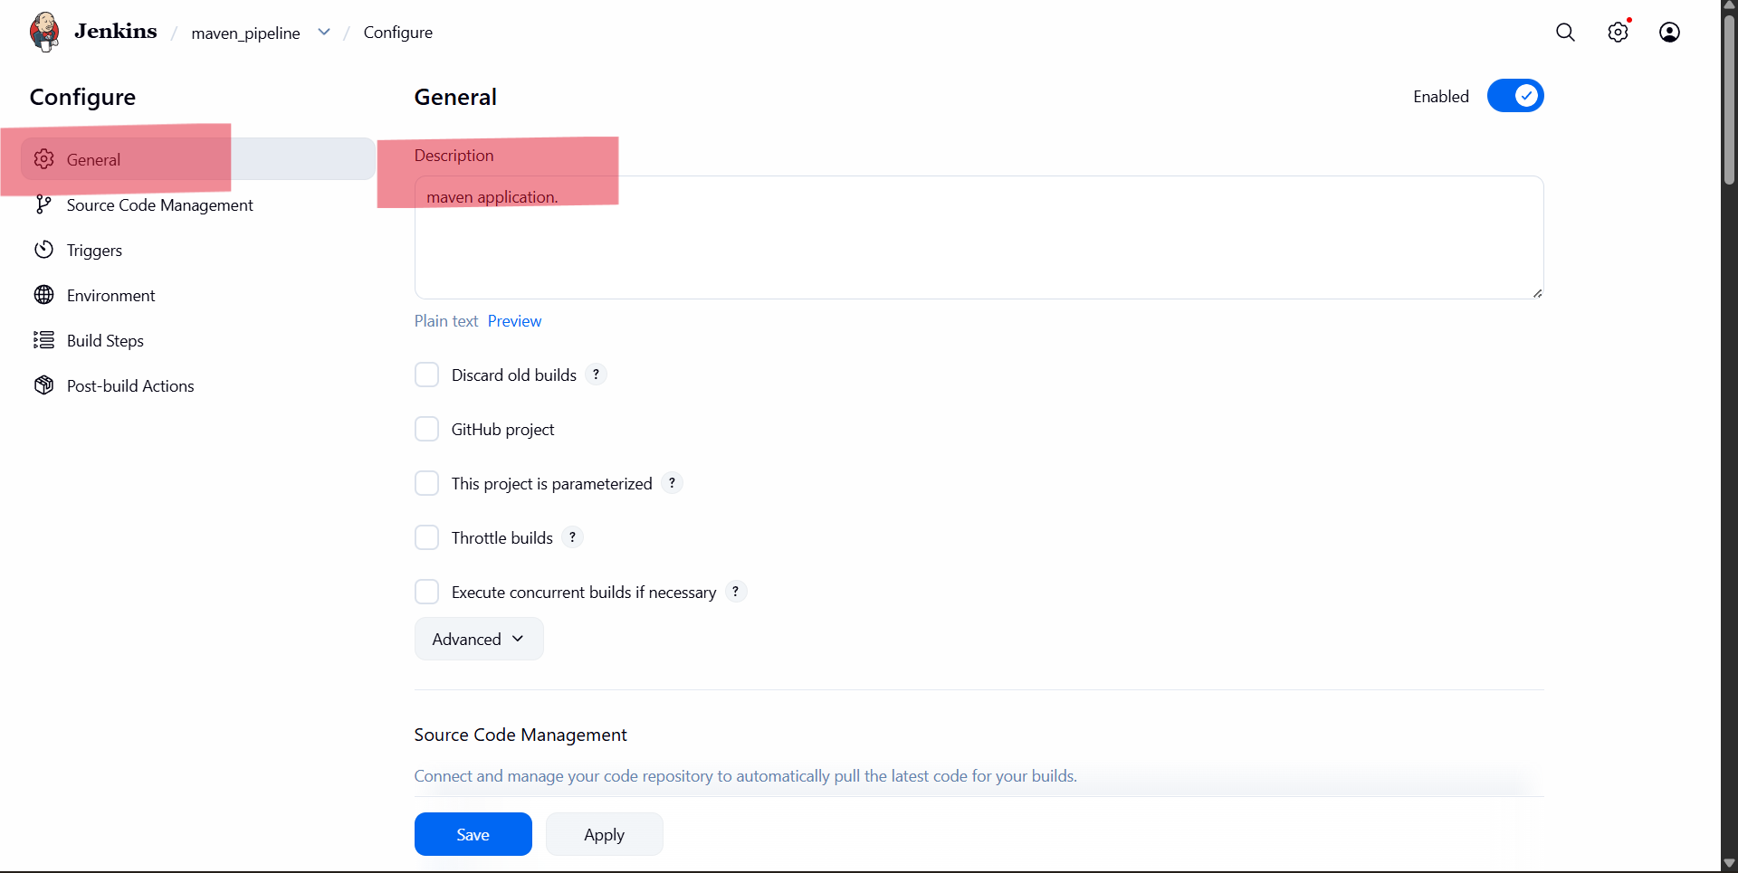

- Next in the source code management select the option “Git”> provide the “repository URL from GitHub”> check the branch specifier (i.e., main or master)
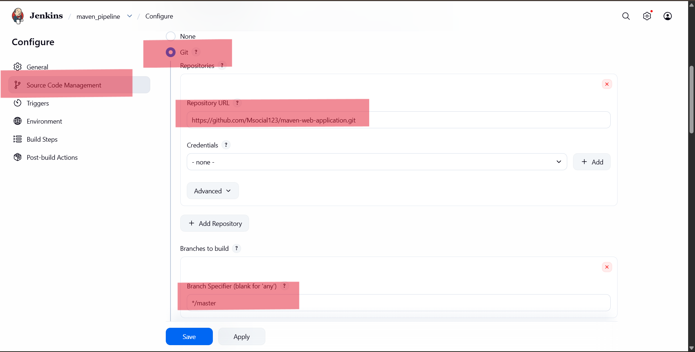

- Skip Triggers and environment> Build steps> Add build step> select “Invoke top-level Maven targets”> provide maven version> In goals enter as “clean package” for war/jar files

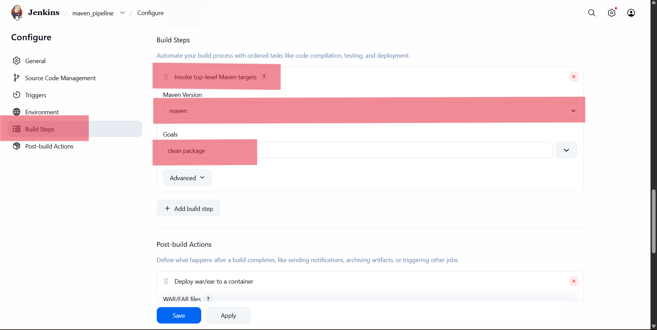

- If the pom file is not in the root file, select this step> click advanced> enter pom file path
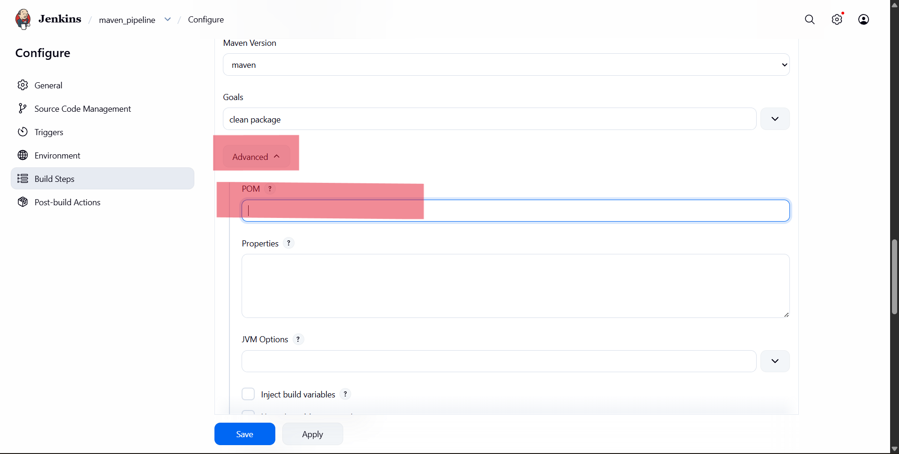

- Next Add post build actions> select “Deploy war/ear to a container”> in “WAR/EAR files option enter ‘**/*.war’”> Add containers> select “Tomcat 9x Remote”> select the credentials (i.e., given before)> give the “Tomcat path as local host number”> save

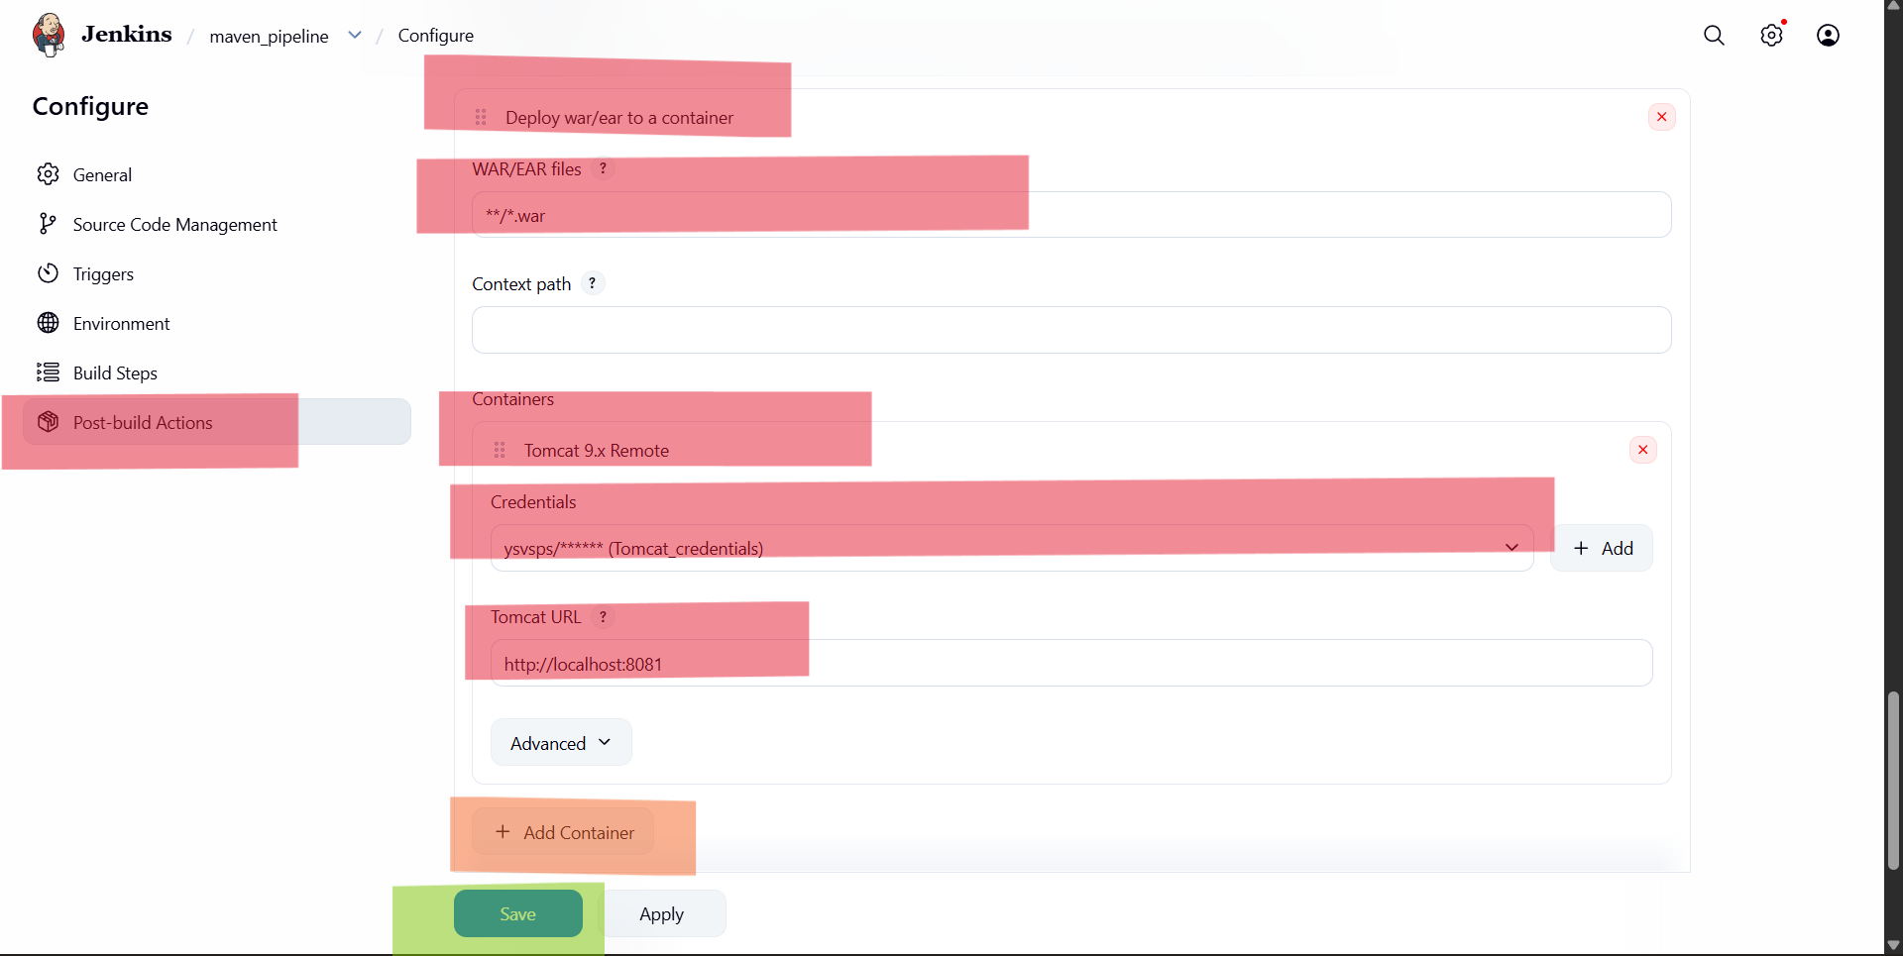

- After saving it will redirect into this page > now click on build now> it will run, showing a number> click on that number

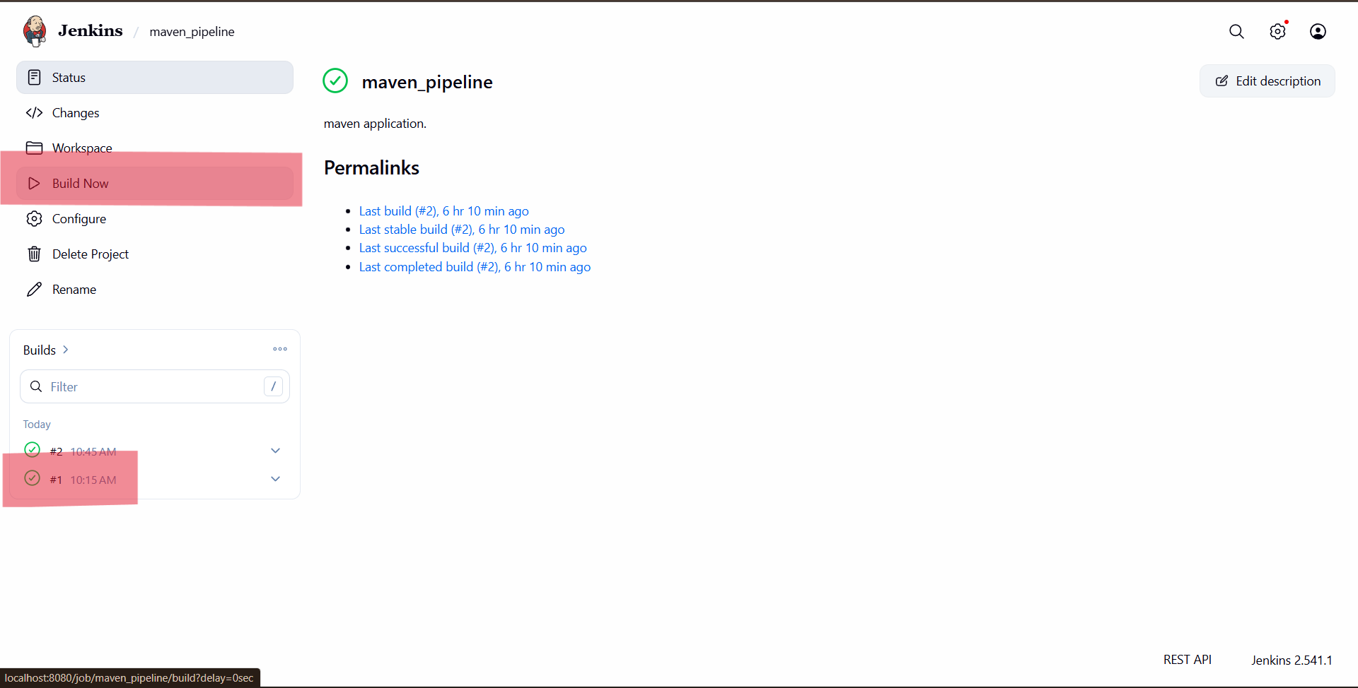

- Now check on Tomcat server, it will show the application> click on that newly created application

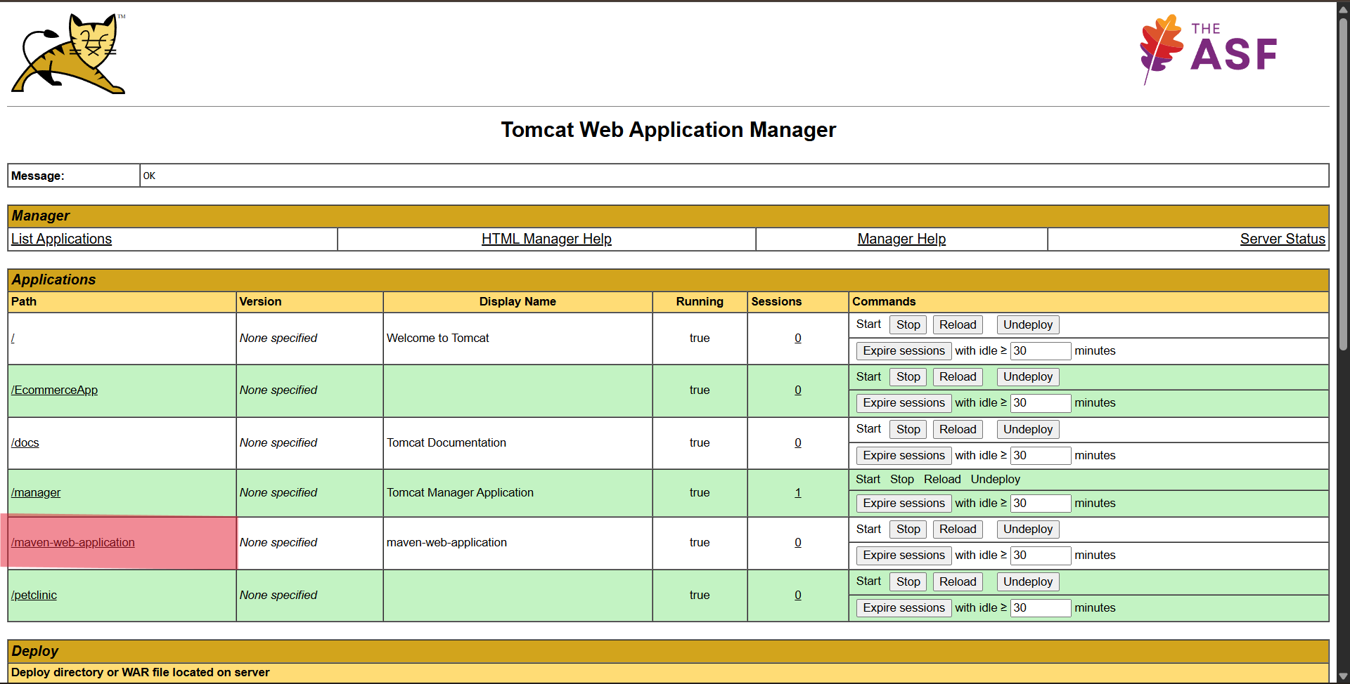

- Finally, we will see the created webpage here.



